**Social Worker Michael Allen Reflects on Years of Service**

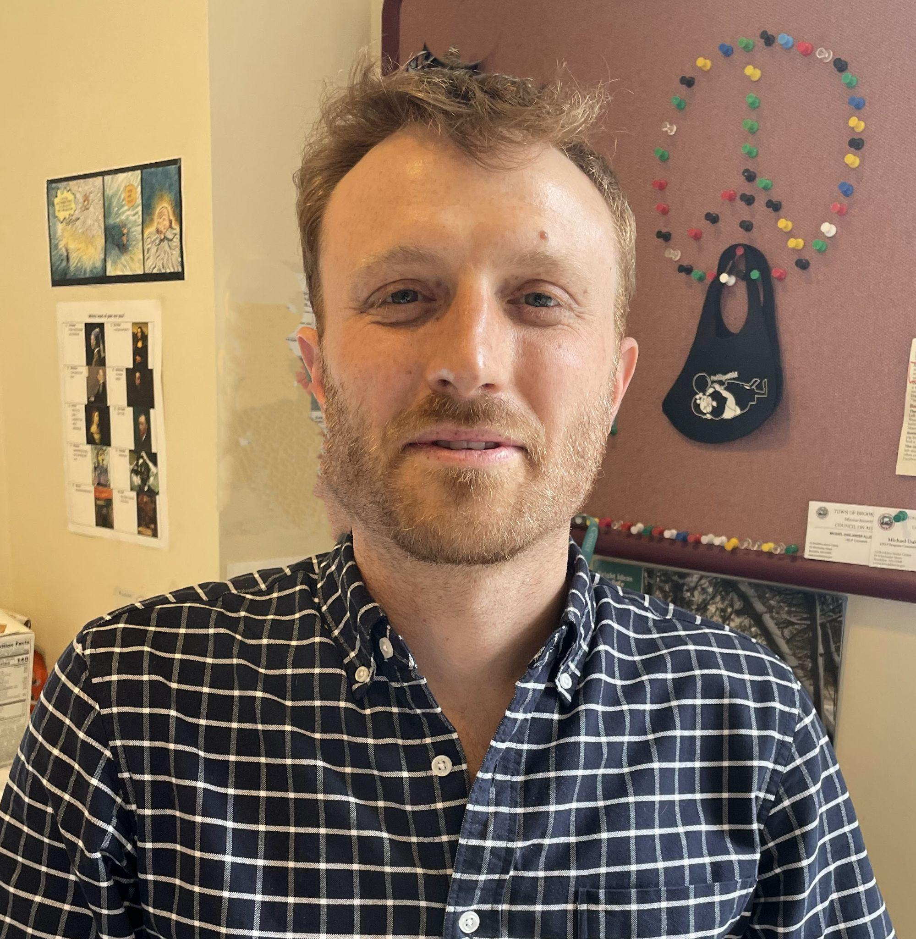

In early May, Council on Aging social worker Michael Allen is wrapping up six years of devoted service in Brookline to embark on new ventures in Washington DC. A Belmont native, Michael got his bachelor’s degree at Bard College. He returned to Massachusetts to work in the State House before deciding to become a social worker. He landed the position in Brookline upon completing his master’s degree at Simmons University in 2018. He shared his experiences, reflections, and thoughts about his time at the Senior Center.

Michael brought a number of special skills to his job, including expertise in mindfulness, group work, and government political systems. His varied responsibilities have encompassed lining up home care workers through the HELP (Home and Escort Linkage) Program, distributing medical devices (such as walkers) through the Equipment Loan Fund (ELF), and providing on-street parking permits for home care workers. He also supported clients through mindfulness and bereavement groups, in addition to individual counseling. Michael’s collaborations with Town divisions have included the Police, Public Health Department and Brookline Community Aging Network.

Michael is proud that Brookline was the first New England community designated Age-Friendly by the World Health Organization. He finds Coolidge Corner one of the best places for older adults to live, offering convenience and resources due to its access to public transportation, services, and shops. The combination of more recent relocators and long-term residents “adds to the richness of the community.”

Michael has witnessed a number of changes while working at the Senior Center. In 2018, Michael found the busy building serving as “a second home” for many. He did not anticipate that a major shift would occur in 2020, when the COVID-19 pandemic struck. Suddenly many programs and services had to move online, and there was a big effort to get residents the help they needed while navigating the health threat.

Since the end of the medical emergency, a greater focus of his work has been around supporting those in need of stable and affordable housing. At the same time, Michael has observed that the 93 Winchester Street building serves as a base for locals. He would like more people to take advantage of the many programs, services, and resources available through the Council on Aging. He sees individuals getting out of the Senior Center what they put into it, by showing up for events, offering ideas for programming, and reaching out for support.

The Center is staffed with about 9 full-time social workers, most of whom have experience addressing challenges similar to those area seniors are undergoing. Michael encourages anyone seeking assistance (for themselves or others) to call 617-730-2777. Typically they will be able to connect with a social worker within one business day.

In addition, Michael feels area residents could make more use of the rich in-person programs, including lunches and movies. He advises those interested to view the Council on Aging website at <https://www.brooklinema.gov/245/Council-on-Aging> , as well as the free monthly *Brookline Beacon* newsletter to peruse the wide array of other offerings and support (<https://www.brooklinema.gov/Archive.aspx?AMID=37> ). He encourages older residents to simply drop by 93 Winchester Street to socialize, grab a cup of coffee, and peruse the gift cart’s offerings.

He hopes that Brookline-ites will soon have greater opportunities to interact across generations and age groups.

When asked what he learned from his time working at the Council on Aging, Michael replied “Balance.” He became more adept at being a dedicated, caring social worker while tending to other areas of his life. He also gained insight into “the human experience,” as clients shared details about their lives with him. Additionally, he identified ways to navigate systems to obtain services - such as housing, food, and health care - for those in need.

As a final thought, Michael stated that “It’s been an honor” to experience people’s lives with them over the past six years. We wish him well in his new endeavors.